**Hostel Management System(Room Allocation)**

**An Engineering Project in Community Service**

**Phase – I Report**

***Submitted by***

**Team Members List**

**1. 20BCE10040 - Aryan Mehta**

**2. 20BCE10058 - Abhinav Kumar**

**3. 20BCE10083 - Arpit Subhash**

**4. 20BCE10798 - Khush Bubna**

**5. 20BCE10878 - Prasoon Kumar**

**6. 20BCE10935 - Akhil Pratap Singh**

**7. 20BCE10956 - Aniwesh Kumar**

**8. 20BOE10014 - Soumitra Lokur**

***in partial fulfillment of the requirements for the degree of***

***Bachelor of Engineering and Technology***



**VIT Bhopal University**

**Bhopal**

**Madhya Pradesh**

**December,2022**



**Bonafide Certificate**

Certified that this project report titled **“Hostel Management System(Room Allocation)”** is the bonafide work of **“**20BCE10040 Aryan Mehta, 20BCE10058 Abhinav Kumar, 20BCE10083 Arpit Subash, 20BCE10798 Khush Bubna, 20BCE10878 Prasoon Kumar, 20BCE10935 Akhil Pratap Singh, 20BCE10956 Aniwesh Kumar, 20BOE10014 Soumitra Lokur**”** who carried out the project work under my supervision.

This project report (Phase I) is submitted for the Project Viva-Voce examination held on 29th December,2022.

**Supervisor**

**Dr. Harish Chandra**

# INTRODUCTION:

* A hostel is an establishment that provides inexpensive food and lodging for a specific group of people, such as students, workers, or travelers.
* As hostels grew in quantity and quality, the development of systems needed to manage and maintain the administration and records of travelers became a necessity.
* The hostel management system is responsible for maintaining the records of students, hostel administration, annual budget, fees, room allotment, mess arrangement, and transaction reports.
* The hostel room allocation system is an important component of the hostel management system, which allocates rooms to students based on their choice of the price of the room, the number of beds in a room, availability of A/C, and size of the room.
* Hostel room allocation systems need to function with efficiency so that students and faculty alike are registered smoothly in the system’s records and face fewer hassles and issues.
* In our search for developing a hostel room allotment system, we consulted many hostellers of VIT Bhopal to give us their insights into how the system could be made more efficient and simple for them.

## MOTIVATION:

* As educational institutions are expanding all over the world and creating hostels for students to live in, systems that record, manage and maintain data about hostellers efficiently, have become an urgent necessity.
* Thus, Hostel management is considered to be the most tedious process as it demands a huge workforce and time.
* Hostel Management System simplifies various managing operations of the hostel. The system can help to keep track of the hostel's daily operations and simplify operations like
  + - * Maintenance of lodging facilities and charges
      * Handling Food, and accommodation
      * Fees for Mess
      * Staff payroll management
      * Finance management
* Students face problems and hassles when they are registering for the room allotment process. If the process involved is not catered to handle and manage a large number of people, confusion is created.
* By consulting the students at the hostel, we gained new insights and identified major problems. Some of the problems were,
  + - Excess time spent by each student for each registration.
    - Lack of a streamlined process.
    - Problems faced when one is not allotted any room due to time constraints.
    - Limitations of manual registration.
* By incorporating the information into our project, we proceeded to search for existing and new solutions to these problems.

## OBJECTIVE:

* The main objective of our team is to create a smooth and efficient hostel management system for room allotment of hostellers.
* The main aim is the creation of a fair system that will ensure that hostellers face minimum conflicts and issues while registering for room allotment.
* This will also help in maintaining transparency between the management and students.
* The easy user Interface will help in ease of usability and also lead to make the choosing and allotment process less complicated.
* To automate each and every activity of the manual system.
* To make it easier for data collection, storage and referencing.
* To store the data of all current students and also the students who had left the hostel.
* To provide a quick response with very accurate information when needed.
* To make the hostel management system more interactive, speedy and user friendly.

# EXISTING WORK / LITERATURE REVIEW: ( 1- 2 Pages)

* For the past few years the number of educational institutions has been increasing rapidly. Thereby the number of hostels are also increasing for the accommodation of the students studying in this institution.
* And hence there is a lot of strain on the person who is running the hostel and software’s are not usually used in this context.
* This particular project deals with the problems on managing a hostel and avoids the problems which occur when carried manually Identification of the drawbacks of the existing system leads to the designing of a computerized system that will be compatible with the existing system with the system which is more user friendly.
* We can improve the efficiency of the system ,thus overcoming the following drawbacks of the existing system.

**DISADVANTAGES OF EXISTING SYSTEM:**

* More human power.
* More strength and strain of manual labour needed.
* Repetition of the same procedure.
* Low security.
* Data redundancy.
* Difficulty to handle.
* Difficulty to update data.
* Record keeping is difficult.
* Backup data can be easily generated.

# TOPIC OF THE WORK:

1. **SYSTEM DESIGN / ARCHITECTURE:**

* **User Module:** This helps the administrator and user to login to the homepage only if password and username matches.
* **Student Module:** This module is used to store student details i.e. information like profile details, contact information, educational details etc. Users can search according to different criteria such as name, course, room number etc.
* **Room Allotment Module:** This deals with allocation of room to students according to education details, section or course. Rooms will be allocated to students and an ID will be generated for it. It will display details of students staying in the room or rooms. When a student leaves the room after the semester, the left date will be also saved.
* **Room Fees Module:** This displays fee records, student dues status and balance amount status. It is also used to renew students' rent every semester.
* **Report Generation Module:** This is provided to view summary detail regarding hostel fees and bills. Students can check hostel fees and bill details by entering the unique hostel ID.
* **Settings Module:** In this module, only the administrator can access. Administrator has a unique account with much special access and permissions over normal users. Module allows add, edit, List of Figures 8 delete and employee records, building block information, room details, course details etc.

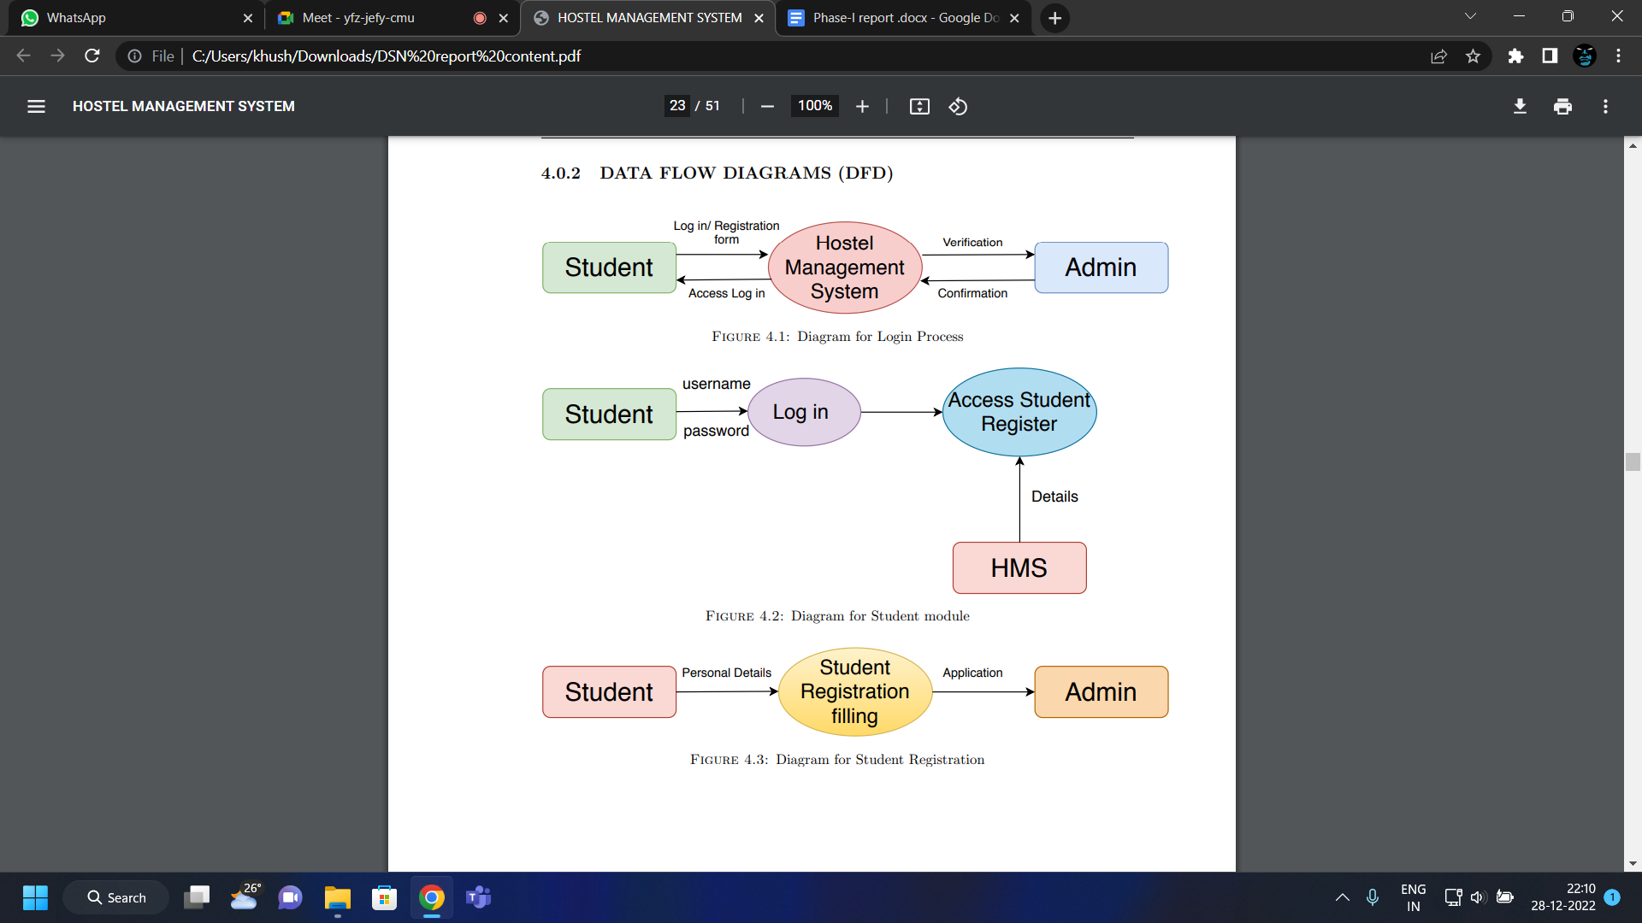

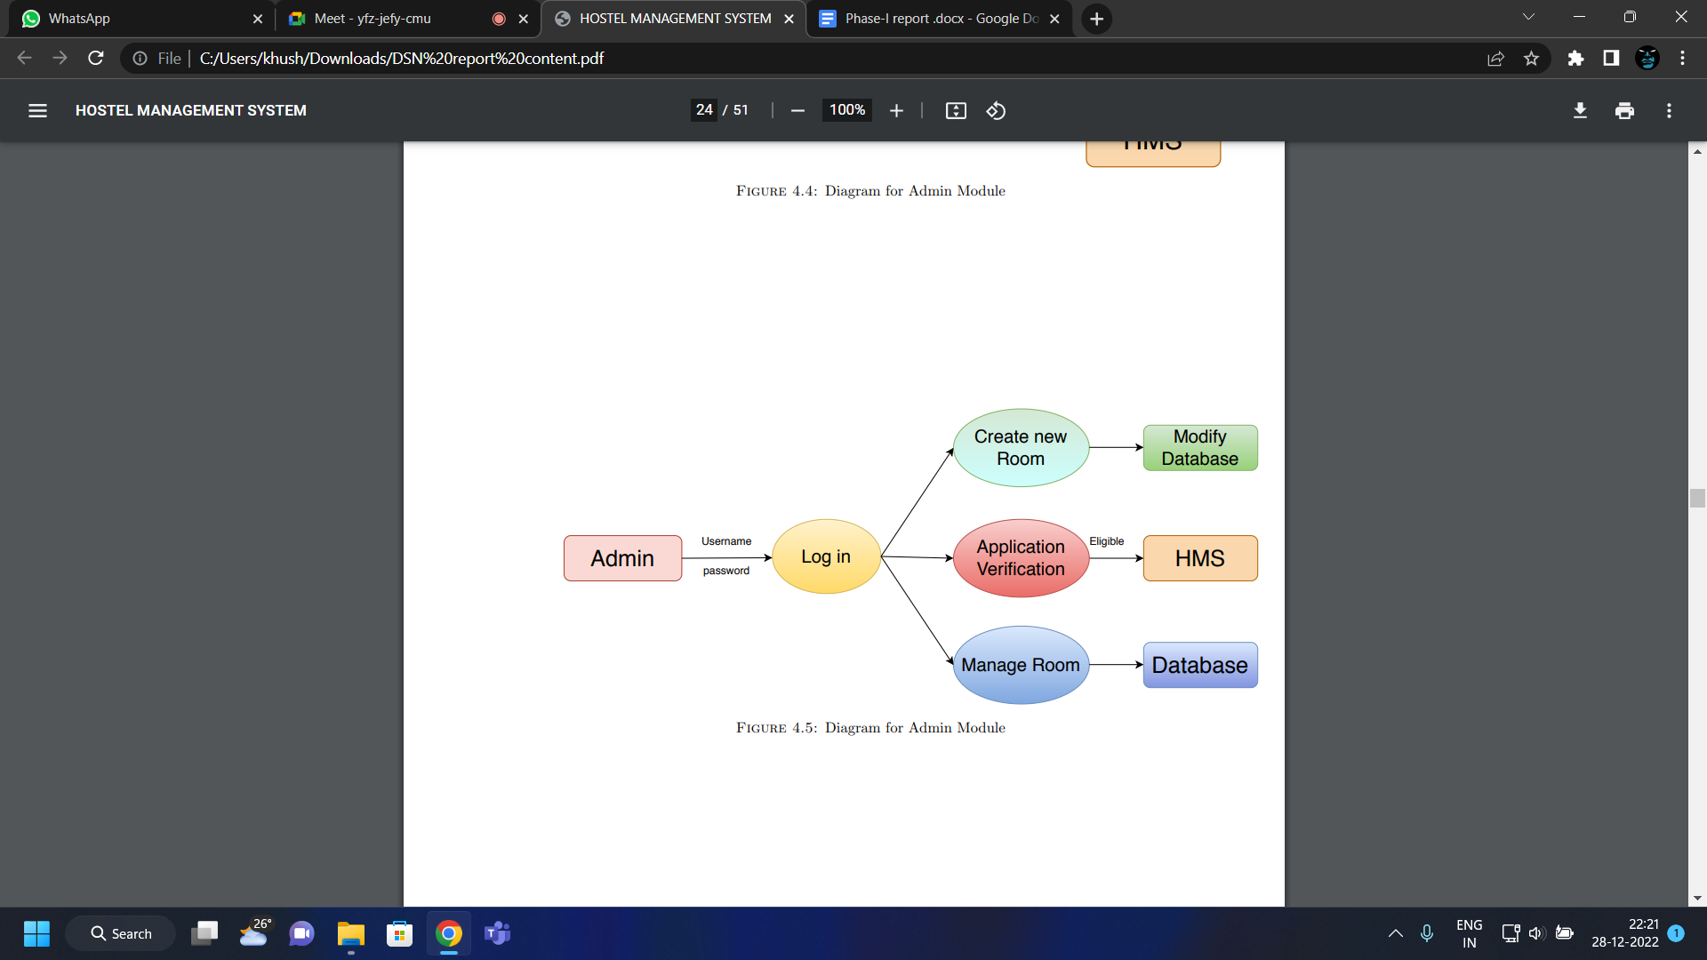

1. **WORKING PRINCIPLE:-**

* Hostel Management System (HMS) is a web-based system for managing various activities in the hostel online.
* It helps in avoiding the problems which occur when carried out manually. It improves the efficiency of the system.
* Ability to manage application, admission, Allotting room and mess bill & hostel bill, student vacation and report generation.
* Advantages of the proposed system over the existing system:
  + Less human error
  + Strength and strain of manual labour can be reduced
  + High security
  + Data redundancy can be avoided to some extent
  + Data consistency
  + Easy to handle
  + Easy data updating
  + Easy record keeping
  + Backup data can be easily generated

1. **EXPECTED RESULTS:**

* Here we have mentioned a brief review of our expected result, So here we have attached the image of the two webpage windows of our hostel allocation website.
* The first one is the registration window where the user will mention his/her details as well as the room preferences and clicks on submit key.
* The second window is where the actual procedure of managing the data and providing the rooms on the basis of choice and availability is done by the hostel allocation management of the colleges.

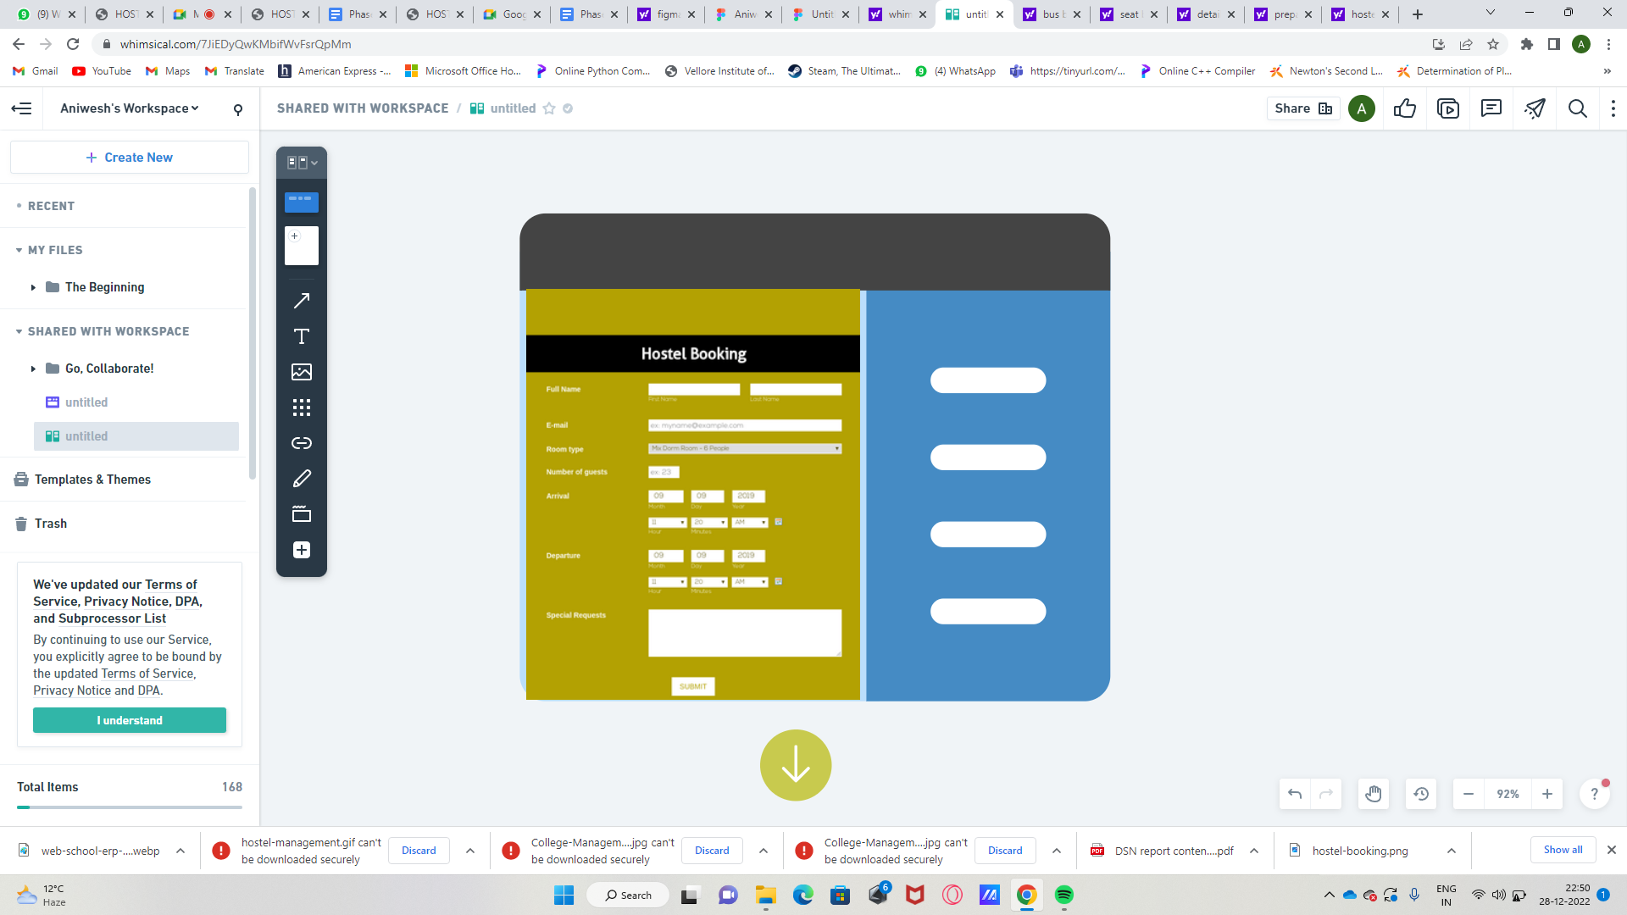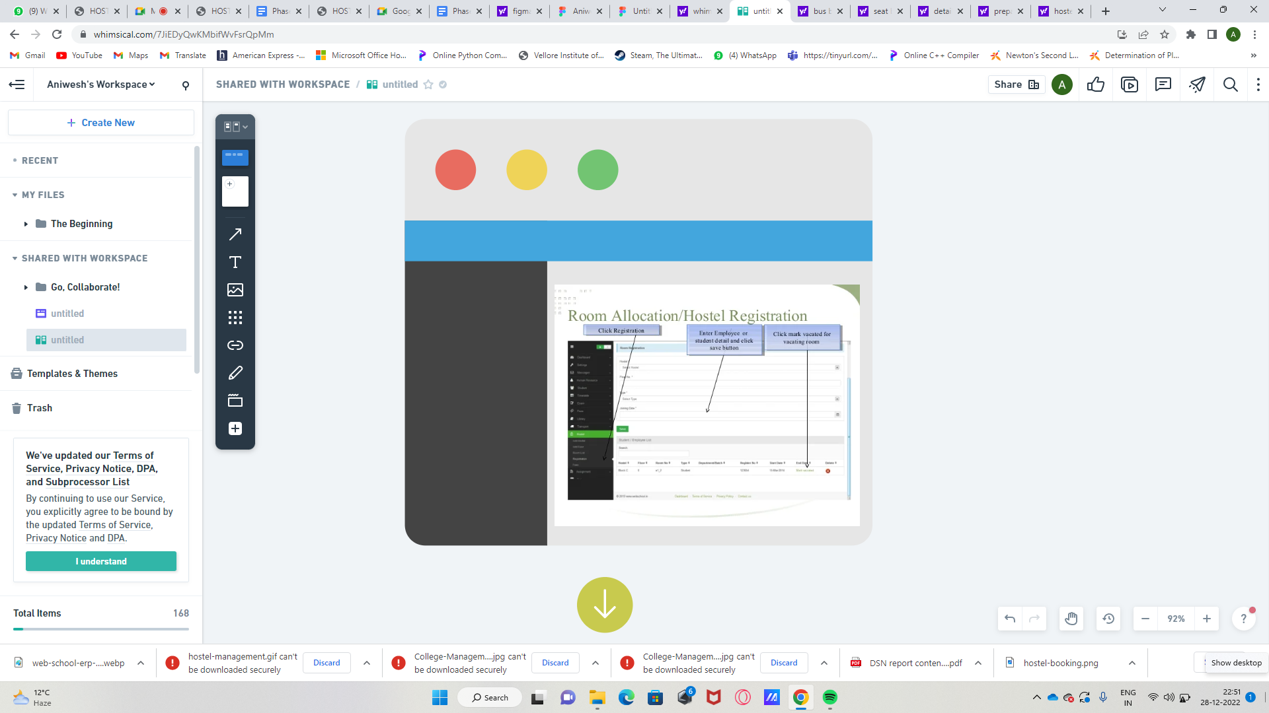

# CONCLUSION

* To conclude the description about the project : The project, developed using PHP and MySQL, is based on the requirement specification of the user and the analysis of the existing system, with flexibility for future enhancement.
* Last few years the educational institutions have increased rapidly. As a result of the accommodation of the students of these institutions, the number of hostels also increased.
* So it is very hard to do all the hostel management activities manually. There is a lot of strain on the person who is running the hostel.
* This hostel management software is designed for those people who want to manage hostel activities easily.
* This particular project deals with the problems of managing a hostel and avoids the problems which occur when carried manually.

# REFERENCE:

1. EMMANUEL ADU BAFFOE JUNE. Hostel Management System. PhD thesis, 2016.
2. Kola Ayanlowo, O Shoewu, Segun O Olatinwo, Olusegun O Omitola, and Damilola Babalola. Development of an automated hostel facility management system. Journal of Science and Engineering, 5(1):01–10, 2014.
3. Kiplimo Changwony. Online hostel management system. 2015.
4. AR Sujana. Hostel management system for Trincomalee Campus. PhD thesis, Faculty of Management and Commerce SEUSL, 2013.
5. MUHAMMED SHAHEER KA. Hostel management system. 2010.
6. Asadullah Khan and Sajid Rashid Ahmad. Desktop is an application for hostel management of punjab university lahore. Journal of Himalayan Earth Science, 45(2),2012.